Implementation of Timer using 8051


LAB # 06

Spring 2024
CSE-307L Microprocessor Based System Design Lab

Submitted by: Ali Asghar
Registration No.: 21PWCSE2059
Class Section: C

“On my honor, as student of University of Engineering and Technology, I have neither given nor received unauthorized assistance on this academic work.”

Submitted to:
Dr. Asif Ali Khan

Date:
29th March 2024

Department of Computer Systems Engineering
University of Engineering and Technology, Peshawar

Task 1:
Use timer to Generate a delay of 15ms

Calculation:
For 15ms delay, subtract 15,000_{dec} from FFFF_{hex}
Hence, we get the starting value of the 16-bit counter, i-e
FFFF_{hex} - 15,000_{dec} = C567_{hex}

Code:
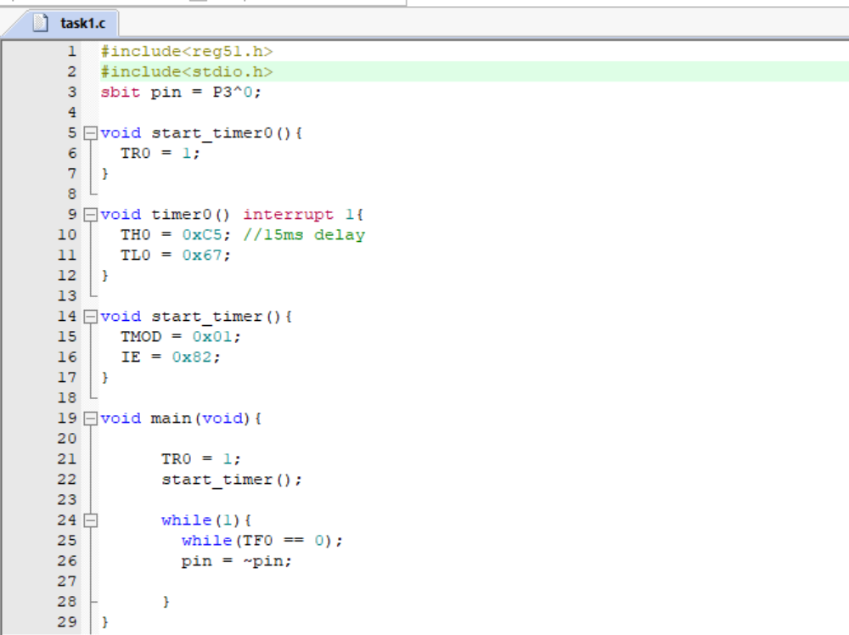

Proteus Simulation:
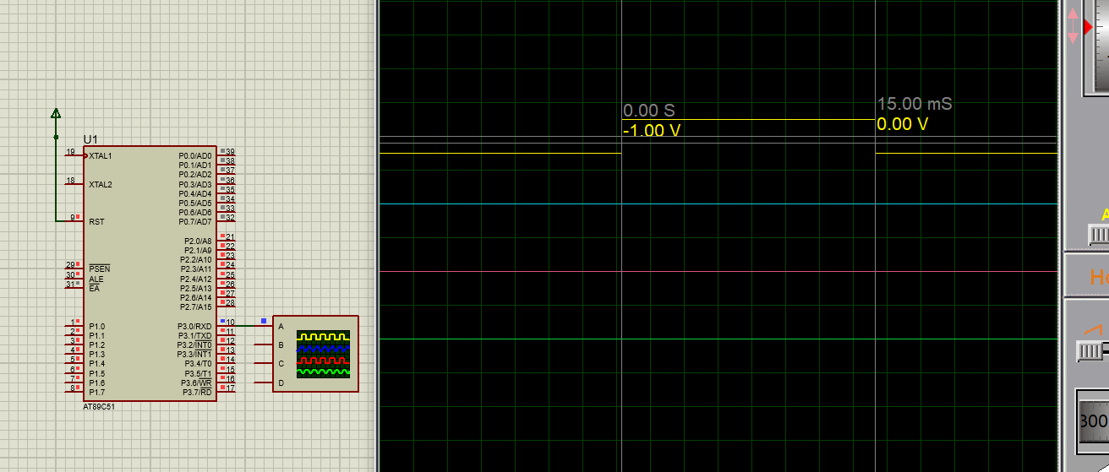

Task 2:
Use timer to Generate a delay of 50ms

Calculation:
For 50ms delay, subtract 50,000_{dec} from FFFF_{hex}
Hence, we get the starting value of the 16-bit counter, i-e
FFFF_{hex} - 50,000_{dec} = 3CAF_{hex}

Code:
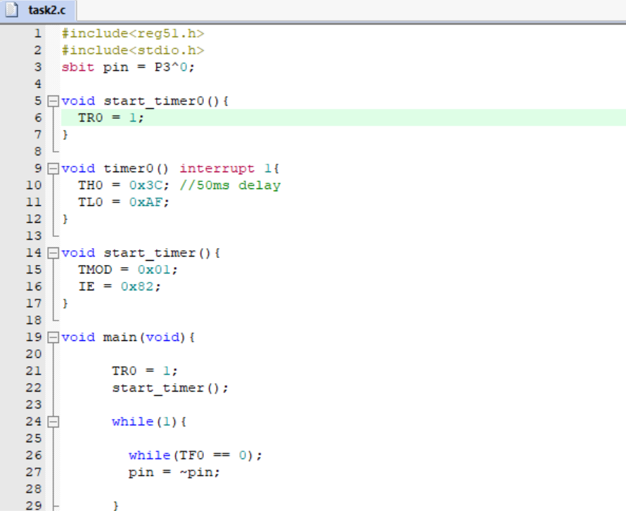

Proteus Simulation:
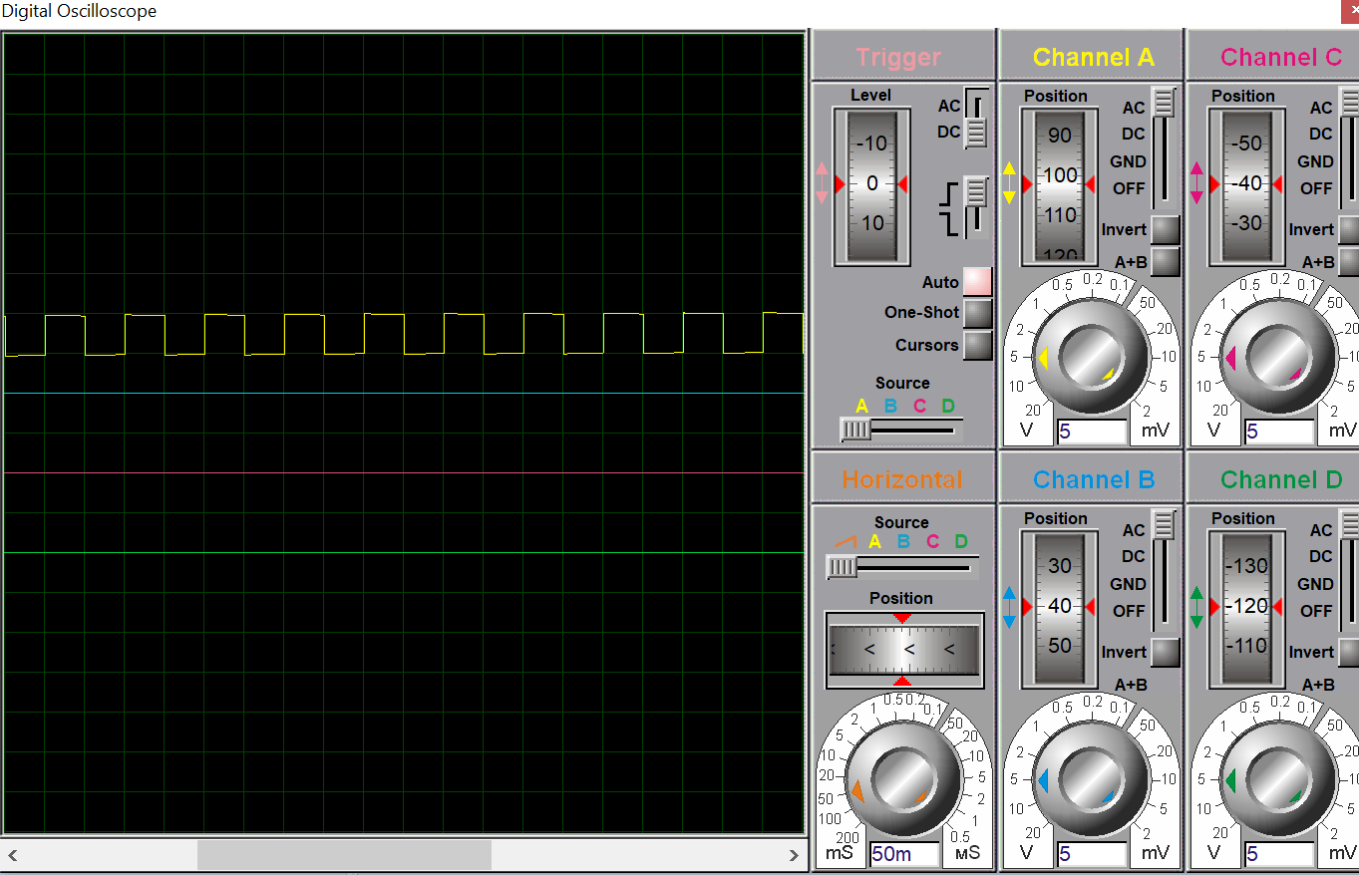

Task 3:
Use timer to Generate a delay of 200ms

Calculation:
We cannot directly create 200ms delay as it is out of the bounds of a 16-bit timer(Max Delay = 65ms approximately). Hence, we will create 50ms delay first and then wait for it 4 times i-e
50ms x 4 = 200ms

Code:
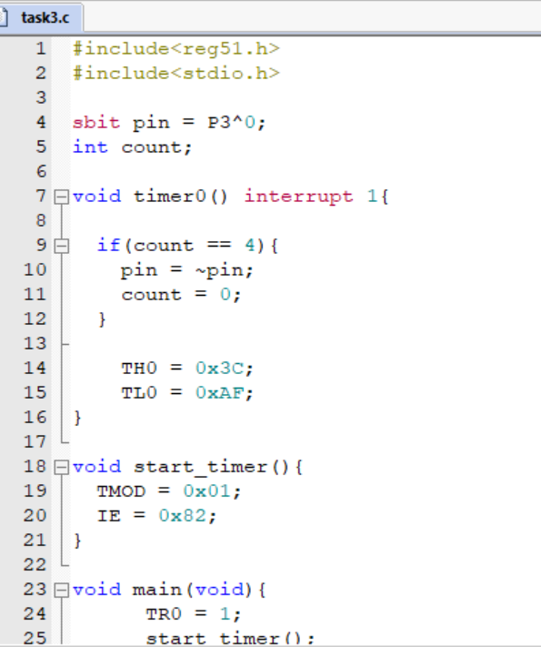
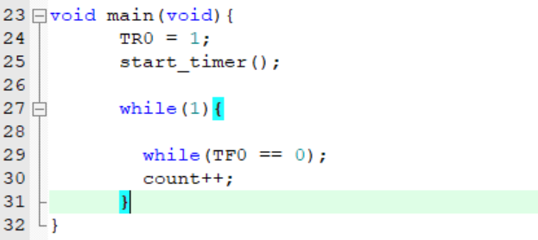

Proteus Simulation:
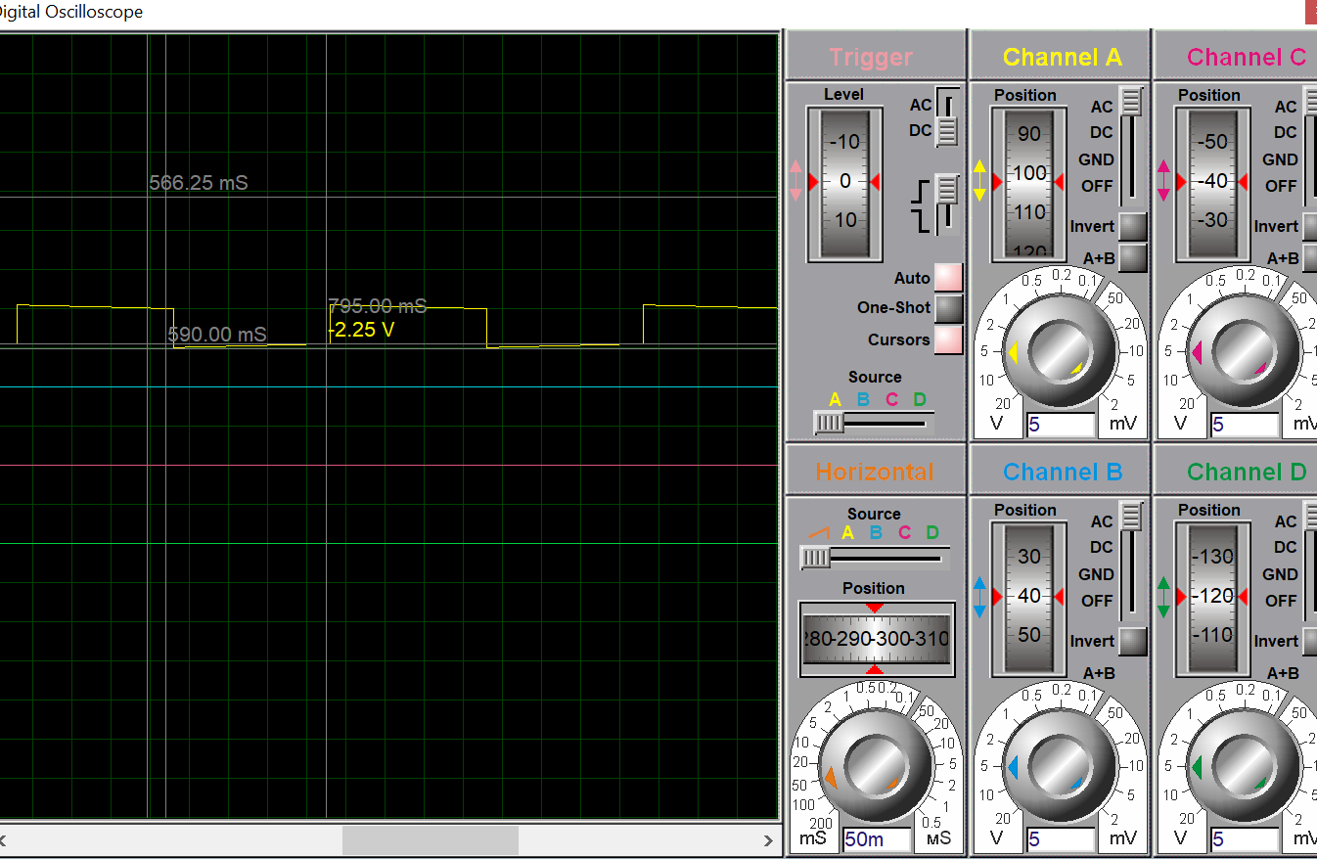

Task 4:
Use timer to Generate a delay of 200µs

Calculation:
For 200µs delay, subtract 200_{dec} from FFFF_{hex}
Hence, we get the starting value of the 16-bit counter, i-e
FFFF_{hex} - 200_{dec} = FF37_{hex}

Code:
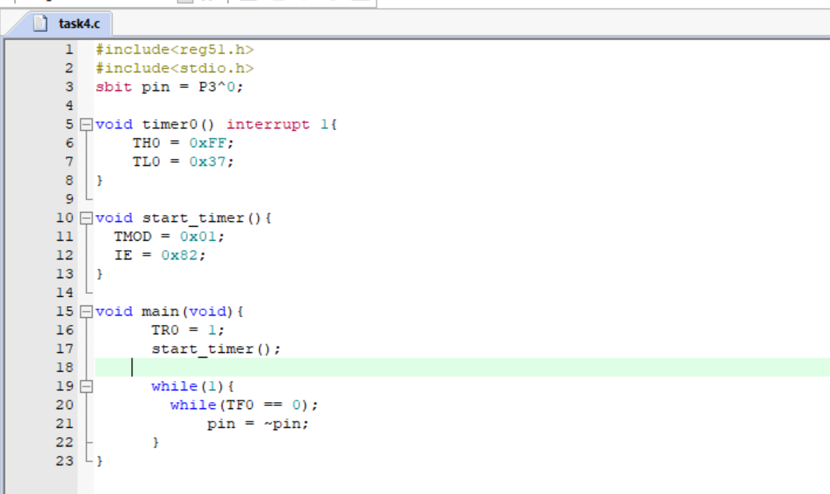

Proteus Simulation:
